BDaaS – Real time data stream processing and analytics using IOT connected devices

Category: Big Data Analytics

**System Diagram**

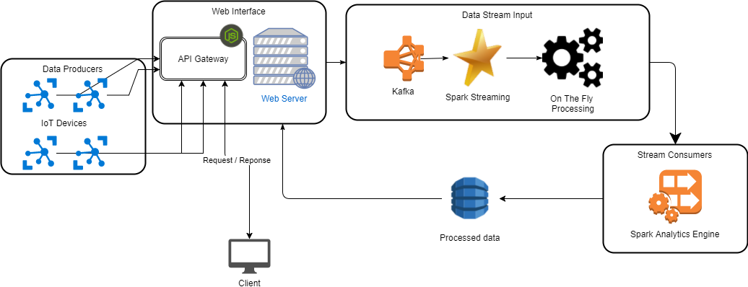

**How to attack the problem – Schedule and milestones**

1. Week 0: (2017-10-9)
   * Define the architecture, platform, and problem to solve
   * Find potential datasets
   * Submit proposal
   * Learn the Apache Big Data frameworks and ecosystems
2. Week 1: (2017-10-16)
   * Setup infrastructure
     + Setup hardware equipment
       - Make environment (Ubuntu, centos)
       - Open port on router to have access to outside world
     + Setup Big Data Ecosystem (SMACK stack)
       - Spark
       - Mesos
       - Kafka
       - Cassandra
     + Setup web API interface (Node, Express)
       - Node.js server REST API
         * Be able to accept POST requests from IOT devices
3. Week 2 (2017-10-23)
   * Setup pipeline
     + Connect web interface (Node.js) to big data engine
     + Feed incoming data into SMACK stack
4. Week 3 (2017-10-30)
   * Develop algorithms for data crunching
   * Machine learning for anomaly detection and predictive analysis
   * Extend API to handle GET requests for analytics queries
5. Week 4 (2017-11-6)
   * Continue general work
6. Week 5 (2017-11-13)
   * Submit Milestone 1 status report
7. Week 6 (2017-11-20)
   * Handle heavy workloads from multiple data sources
   * Fix any bugs
8. Week 7 (2017-11-27)
   * Continuous improvements.
   * Have functioning system ready for demo
9. Week 8 (2017-12-4)
   * Work on final report and demos
10. Week 9 (2017-12-11)
    * Wrap up final project report and demo